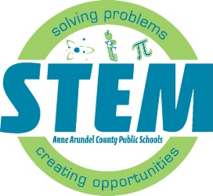**STEM Middle School 2024 Summer Program Locations**

Central Middle School STEM 🡪 Magothy River Middle School

Old Mill Middle School South STEM 🡪 Brooklyn Park Middle School

Lindale Middle School STEM 🡪 Brooklyn Park Middle School

|  |  |  |
| --- | --- | --- |
| **Summer Program Dates** | **Grade (in the 2024-25 school year)** | **Summer Program  School Location** |
| June 24th- 27th | 6th Grade | Magothy River & Brooklyn Park Middle Schools |
| June 24th- 27th | 8th Grade  **Make- up week** | Brooklyn Park Middle School  Only |
| July 8th- 11th | 7th Grade | Magothy River & Brooklyn Park Middle Schools |
| July 15th- 18th | 8th Grade | Magothy River & Brooklyn Park Middle Schools |
| July 22nd- 25th | 7th Grade | Magothy River & Brooklyn Park Middle Schools |
| July 29th – August 1st | 8th Grade | Magothy River & Brooklyn Park Middle Schools |
| July 29th – August 1st | 6th & 7th Grade  **Make- up week** | Magothy River & Brooklyn Park Middle Schools |

**\*No Transportation will be available for camps in the week of June 24th.**

**STEM Middle School Summer Program School Site Addresses:**

Magothy River Middle School: 241 Peninsula Farm Rd, Arnold, MD 21012

Brooklyn Park Middle School: 200 Hammonds Ln, Brooklyn Park, MD 21225

**AACPS Summer 2024 website:** [**https://www.aacps.org/summer**](https://www.aacps.org/summer)   
**AACPS STEM website:** [**www.aacps.org/stem**](http://www.aacps.org/stem)

